# logo black no sloganPro-Line Membership

**Terms:**

* Under 150,000 miles at the time of the policy commencing.
* No electric or hybrids.
* The vehicle has to pass a pro-line 142 point safety check before the policy commences.
* vehicle has to be less than 15 years old.
* Total weight to be under 3000kg
* The vehicle’s current value has to be under £40,000.
* The vehicle has to have proof of a service being carried out within the last 12 months.
* The vehicle has to have a minimum of 3 months MOT.
* No imports.
* No modified vehicles.

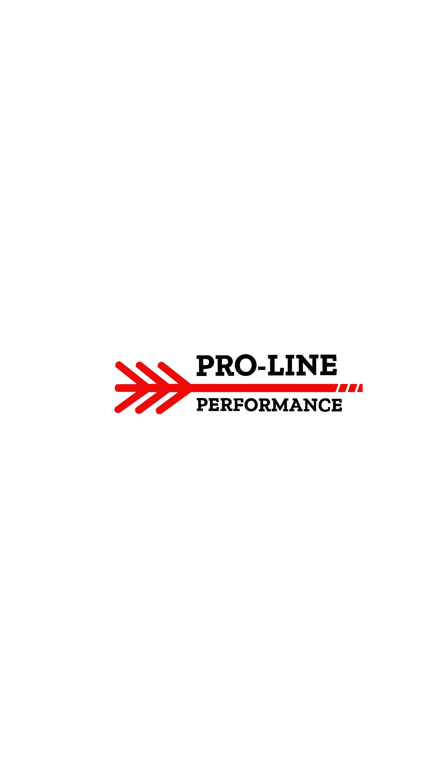

**What is covered**?

**Warranty assist cover :**

(see page 4-5)

**Pro-line support cover :**

* 1 x Silver Service every 6 month of warranty.
* Brake discs + brake pads
* Punctures
* Roadside assistance
* Clutch
* Diagnostics
* Recovery (up to £120)
* Battery
* Bulbs
* Wipers
* Fuses
* Wing mirrors

## Gold Cover

Only components approved by the manufacturer and fitted by their agents are covered. Any component not specifically mentioned is not covered.

### Electrics

Alternator, electric window motors, engine cooling fan motors, sunroof motor/ hydraulics, horn, indicator flasher relay, and starter motor.

### Electronic control units (ECUs) & computers

The engine management ECU and any other computers that directly control your vehicle’s alarm and immobilisation functions, that were originally fitted to your vehicle when it was first manufactured are covered (upgraded or revised software and firmware, including software and firmware patches and updates, relating directly or indirectly to any components of your vehicle and any retro-fitted ECUs & computers are not covered.)

### Braking system

Anti-lock braking system (ABS) pump & control unit, calipers, master & wheel cylinders, pressure reducing & proportioning valves, and vacuum servo.

### Casings

Casings are covered provided they have been damaged as a direct result of the failure of a covered Component.

### Clutch

Clutch cable, master & slave hydraulic cylinders and pedal assembly.

### Cooling systems

Engine cooling water radiator, heater radiator, thermostat & housing, viscous cooling fan couplings and water pump.

### Engine

All internally lubricated parts are covered including: Camshafts & bearings, camshaft followers & rockers (including hydraulic lash adjusters), connecting rods & bearings, crankshaft & bearings, cylinder block, cylinder bores & liners & seals, cylinder heads, internal bushings & bearings, oil pump & drive, pistons & rings, timing gears, chain, tensioner, valves, springs & guides (burnt or pitted valves and valve seats are not covered).

### The following engine parts are also covered:

Crankshaft pulley and cylinder head gasket.  
Camshaft drive belts are covered as follows:  
Camshaft drive belts and tensioners (subject to documented proof that the last due change of camshaft drive belt has taken place as specified by the manufacturer’s recommended servicing schedule).

### Flywheels & drive plates

Flexible drive plate for the automatic transmission’s torque converter, solid & dualmass flywheels (flywheels damaged by clutch friction plates are not covered) and starter ring gear.

### Fuel system

Air flow sensors and meters, fuel gauge sender unit, fuel pressure regulators & accumulators, fuel pumps (including pre-pumps, low, high pressure pumps & injection pumps), injectors (including petrol, diesel & single-point injectors.

### Gearboxes

(Including automated manual gearboxes, automatic gearboxes, four wheel drive transfer gearboxes, hybrid transaxles, manual gearboxes and transaxles.)  
Automatic transmission brake bands & clutches & modulator valves, drive chains, gearlever, gears, hydraulic gear-shift governors & internal servos & valve blocks, internal bearings & bushes, oil pumps, selector forks, shafts (all, including extension shafts), synchromesh hubs and rings and torque converter.

### Ignition system

Camshaft sensors, crankshaft sensors and ignition coils.

### Oil Seals and Gaskets

The engine crankshaft rear oil seal and the main gearbox input shaft oil seal are both covered and other oil seals and gaskets that would necessitate the removal of the engine, a gearbox or a final drive unit to carry out repairs are all covered subject to any oil leak from them being sufficiently advanced that oil can be seen to be dripping (slight leaks causing only oil misting or staining are not covered).

### Steering

Column shaft & tilt mechanism & couplings, hydraulic pumps & reservoir & pressure pipes, steering & idler boxes, rack and pinion assembly (including hydraulic rams and electric motors) and track rods & track rod ends.

### Suspension

Wheel bearings

### Transmissions

(including front & centre & rear differentials, front & rear live axles and drive shafts.)  
Constant velocity joints, crown wheels & pinions, differential gears & thrust washers, external drive shafts, internal bushes & bearings (including wheel bearings) & shafts, internal parts of differential locking mechanisms, propeller shafts & propeller shaft couplings & centre bearings and universal joints.

### Turbocharger

Turbocharger units